User defined object in JavaScript as well as TypeScript

Object : any real world entity.

Property or state -🡪 have

Person

Behaviour 🡪 do/does

Bank

Car

Animal

Customer

Product

To implements these object practically in JavaScript as well as typescript we can follow

3 ways.

1. Literal style object creation

This style we use when we want only property for that object.

1. Function style object creation till ES5
2. Class style object creation from ES6 onward we are using class style.

this is a keyword which refer to current object.

Function style and class style diagram

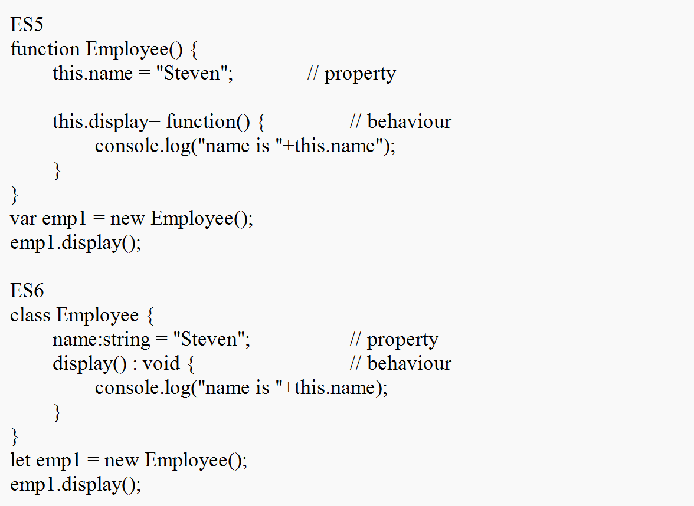

ES6 with class style it supports constructor concept.

Constructor : it is a type of special function which we can write inside a class.

Constructor is use to create the memory.

If class contains one or more than one functions we need to call those function using object to perform a task.

But constructor no need to call it will call automatically when we create the object of that class.

Or memory.

If we want to write constructor in typescript class we have to create the function with name as constructor.

Typescript modules : modules is a collection of variable, function, classes etc. with the help of modules we can achieve separation concern. Means we can write the code in more than one file base upon that code functionality. Using import and export with help of modules we can connect all .ts file together to develop the application.

create folder with typescript module example

abc.ts

export function display1() {

console.log("dislay1 funtion part of abc module");

}

xyz.ts

export function display2() {

console.log("dislay2 funtion part of xyz module");

}

main.ts

import { display1 } from "./abc";

import {display2} from "./xyz";

console.log("main file")

display1();

display2();

tsc main.ts

node main.js

typescript module with same function name in different files

create folder with typescript module example

abc.ts

export function display1() {

console.log("dislay1 funtion part of abc module");

}

export function display() {

console.log("display function in abc module")

}

xyz.ts

export function display2() {

console.log("dislay2 funtion part of xyz module");

}

export function display() {

console.log("display function in xyz module")

}

main.ts

import { display1,display } from "./abc";

import {display2,display as dis} from "./xyz";

console.log("main file")

display1();

display(); // abc display

display2();

dis(); // xyz display as alias dis

tsc main.ts

node main.js

Angular : Angular is an open source web framework provide by Google.

Design pattern : best practise.

Framework provide implementation for design pattern. If we develop any application using framework. 60 to 70% task taken care by framework. But framework it not final product it is a template we need to write the remaining code to make final product.

Angular is use to create SPA (Single Page Application).

In Single page application it will load only part of the web page rather than whole page or whole dom.

Multi page application.

Index.html welcome.html

This page contains its own dom this page contains its own dom.

We can use link, button, submit button

Etc

Angular internally use html, css and typescript.

Google provided angular cli (command line interface) which help to create the project.

To enable angular cli we need to take the help of npm (node package manager)

npm install -g @angular/cli we enable angular cli (ng command enable)

or

sudo npm install -g @angular/cli (unix or mac)

@angular/cli is a node js module which help to create the angular project.

ng version

create folder with name as angular projects

to create project using ng command

open the command prompt inside that folder.

ng new project-name

example : ng new demo-app

routing -🡪 No

style -🡪 CSS (enter)

after project created move inside a project folder using command as

cd project-name

example cd demo-app

to run the project

ng serve -open this command is use to compile the project and run with

default browser with url as http://localhost:4200